**Abstract guidance for all submissions that require an abstract**

A. First,a,b B. Anotherone,a G. E. Presenting,a,c and K. B. Lasta

*a: University of City_L, Country_X;   
b: Big University of Science, Uni_Town_M Country_Y;   
c: Spin Institute, Town_N, Country_Z.*

Every author knows (or should know) best how to prepare their abstract in order to convey their message to the audience in the most efficient way. So, this template is provided to aid the task of preparing your submission, rather than as a prescription for what to do. Its pdf is posted online to show where your abstracts would be located once accepted; in MS Word, it will be available once you log in to your account. The content and form of your abstract is your sole responsibility, and you can, of course, use any software to produce your abstract and then submit the resulting pdf file. We will however insist that the abstract (excluding references [[1],[2]] and acknowledgements) fits within one A4 page, is legible and reasonably formatted (in a broad sense), is relevant, and contains (i) TRTM 2024 header; (ii) title; (iii) author names, each with all affiliations; (iv) the format of presentation / submission; and (v) body (even if just a sentence).

During submission, you will need to indicate the format of your presentation as one of the following.

**Posters**:   
a complete result – a report on a complete research study of significant scientific value;   
a preliminary report for ongoing research that would benefit from additional discussion and insight; a new project, team, or laboratory for a presentation of a new (typically, collaborative) research project, or a newly established laboratory / team and their roadmap.

**Self-nominations for keynote talks:**an in-depth report of a recent discovery or discoveries; a roadmap; or a tutorial.

You can add supplementary data to your submission: upload a file directly on the platform, retrieve a document available from the URL or embed html code (e.g. video deposited elsewhere).

To participate in TRTM 2025 without giving a presnetation, simply email the TRTM secretary to inform us about your intention.

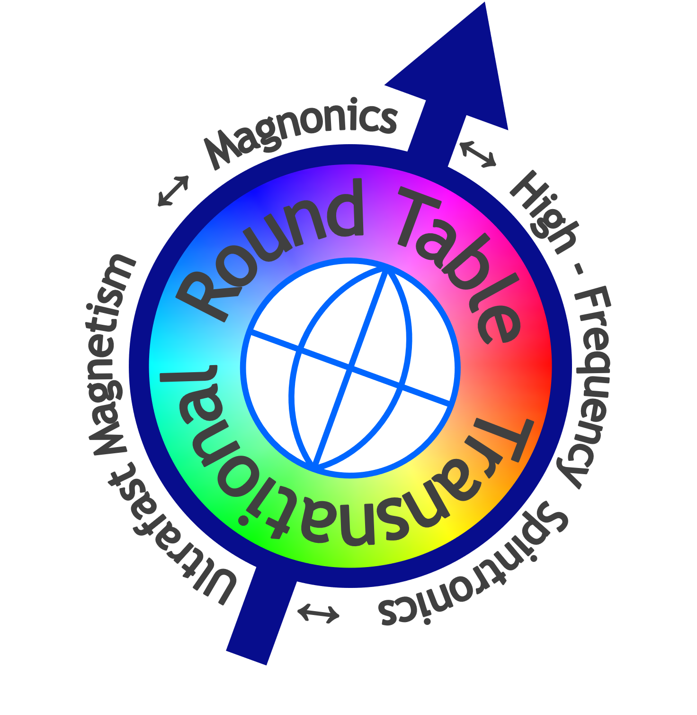

Fig. 1. (left) The TRTM logo: the arrow symbolises a spin; its tilt hints at that of the rotation axis of the Earth shown by the globe; the colour wheel may denote either the azimuth, or phase (of rotation, precession, oscillation, wave), or the equality, diversity, and inclusion as the TRTM’s core values. The dominance of the round shapes and axial symmetry stress the Round Table format of the conference. (right) The TRTM 2026 logo: the spinning top symbolises angular momentum, and the magnifying glass symbolises its scientific scrutiny.

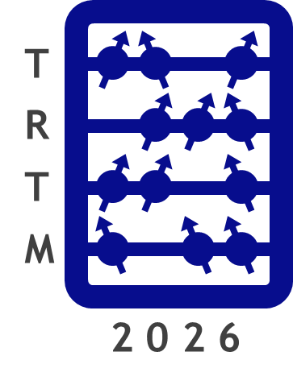

1. [] B. Anotherone, et al, *Realisation of an ultrafast nanoscale all-magnon device for super-pooper computing*, J. High-Impact Research **111**, 222333 (2019).
2. [] K. B. Thoroughly, M. Modest, and J. Omniunknown, *Technology that might make ultrafast nanoscale all-magnon devices feasible*, J. Reproducible Results **12**, 345678 (2029).